Effortless Effort? Investigating the Cognitive Impact of Generative AI Assistance on Student Learning Across Asia and Europe

Abstract
The rapid integration of generative artificial intelligence (GenAI) tools into higher education is transforming how students learn, perceive difficulty, and develop core cognitive skills. From Bangladesh to Hungary, students increasingly rely on systems like ChatGPT to assist with assignments, explanations, and even creative tasks. However, this pedagogical shift raises a critical question: are students accurately assessing their mental effort and cognitive engagement when using AI, or are they experiencing an “effort illusion”, believing learning is easier than it truly is? This study investigates how GenAI assistance, particularly ChatGPT-4.0, affects students’ perceived mental effort, experienced cognitive load, and metacognitive awareness across increasingly complex educational tasks. Drawing on a sample of 196 university students from diverse institutions in Bangladesh, Hungary, and Indonesia, we explored how GenAI-facilitated learning compares to traditional learning approaches in terms of perceived effort, learning performance, and students’ ability to self-monitor their understanding. As students transition from basic recall tasks to complex problem-solving, using Bloom’s revised taxonomy, we examined whether GenAI alters the nature and intensity of their cognitive engagement.
Keywords: Generative Artificial Intelligence, Cognitive Load Theory, Learning Outcomes, Metacognition, Educational Technology, Bloom’s Taxonomy
- Introduction
This chapter aims to examine the role of generative artificial intelligence (GenAI) in higher education, with a particular focus on its cognitive implications for university students (Jarrahi et al., 2025; Ukwandu et al., 2025; Xia et al., 2025). Rather than providing a broad overview of artificial intelligence, the chapter concentrates on how GenAI tools are used in learning contexts and how they influence students’ learning effort, cognitive load, and metacognitive awareness. To achieve this, the chapter first outlines the educational relevance of generative AI, then situates the research within international higher education contexts, and finally identifies the specific research gap addressed by the study (Law, 2024; Huh et al., 2025; Yildiz Durak, Kaya and Ursavaş, 2025). The chapter further desribes the research methodology, descriptive and inferential analysis, and implications for different stakeholders. The chapter also recognizes the limitations of the study.

Generative AI has become an increasingly influential technology in education due to its capacity to generate human-like text and image, provide immediate feedback, and support personalized learning experiences (Borović et al., 2024; Bittle and El-Gayar, 2025; Martin et al., 2025; Park, 2025). Recent advances in natural language processing and machine learning have enabled the development of tools that assist students in academic writing, problem-solving, and self-regulated learning. A major milestone in this development was the emergence of Generative Pre-trained Transformer (GPT) models developed by OpenAI, which demonstrated the potential of large language models for educational applications (Baig and Yadegaridehkordi, 2024; Qadhi et al., 2024; Saúde, Barros and Almeida, 2024). Among these tools, conversational agents such as ChatGPT have gained widespread adoption in higher education (Bobula, 2024), offering new forms of interactive and student-centered learning support. At the same time, the integration of GenAI in higher education raises important pedagogical and cognitive questions (Phokoye et al., 2025). While AI-based tools can enhance efficiency, accessibility, and feedback quality, they may also alter students’ cognitive engagement by reducing the mental effort required for routine academic tasks (Hojeij, Kuhail and ElSayary, 2025). These changes highlight the need to examine not only performance-related outcomes but also deeper cognitive processes associated with learning (Fisher et al., 2025).

This issue is especially important in international contexts where higher education systems differ in pedagogy, technological openness, and regulation. Institutions in Bangladesh and Indonesia have rapidly adopted GenAI, often driven by scalability and access (Aziz et al., 2024; Qadhi et al., 2024; Kosmyna et al., 2025). In contrast, systems such as in Hungary place stronger emphasis on academic integrity and ethical governance. Despite these differences, institutions across regions face a shared challenge: ensuring that students continue to engage in deep learning and critical thinking as AI tools increasingly support or automate cognitive tasks. Existing research on GenAI in education has largely focused on measurable academic outcomes, such as grades, task completion speed, and information access (Rahman and Watanobe, 2023; Ninghardjanti et al., 2025). However, the metacognitive dimensions of AI-supported learning remain underexplored. In particular, limited attention has been given to how GenAI influences students’ awareness of their own cognitive processes, including perceived learning effort, mental load, and long-term knowledge retention. Addressing this gap is essential, as metacognitive competence is a key factor in effective learning and lifelong professional development. Building on earlier exploratory research conducted shortly after the public release of ChatGPT (Baig and Yadegaridehkordi, 2024; Wang et al., 2024). This study extends the analysis to a multi-country comparison, examining how GenAI affects cognitive load and perceived learning effort among university students in Bangladesh, Indonesia, and Hungary, and offering a broader understanding of impact of GenAI in higher education beyond performance outcomes.

- Literature Review
2.1 Generative AI as a Disruptive Force in Global Higher Education
Generative Artificial Intelligence (GenAI), defined as a class of technologies capable of producing novel content such as text, images, or code in response to user prompts (Liu and Zhong, 2025; Zhao et al., 2025), has profoundly reshaped the landscape of higher education. The public release of tools such as ChatGPT in late 2022 accelerated GenAI’s rapid adoption in academic settings, outpacing institutional policy responses and creating a global “policy vacuum” (Weale, 2025). This vacuum has intensified concerns regarding student learning outcomes and higher-order thinking skills.
A central tension in GenAI adoption is the “Paradox of Perceived Ease.” On one hand, evidence suggests GenAI is highly effective as a learning aid; a comprehensive meta-analysis of 51 studies found a "large positive effect" on student academic performance (Wang and Fan, 2025), with students reporting benefits such as time efficiency and instant feedback. However, this perceived efficiency conflicts directly with educator and scholarly concerns regarding the erosion of essential higher-order thinking skills such as cognitive, creative, and critical skills (Damme and Zahner Doris, 2022; Alkhater et al., 2025; Prothero, 2025; Ismeirita et al., 2025).
2.2 Theoretical Frameworks: The Cognitive Basis of Effort and Learning
This study is grounded in Cognitive Load Theory (CLT), the Misinterpreted-Effort Hypothesis (MIEH), and the ideas of illusion of learning and desirable difficulties.
Cognitive Load Theory, was developed by John Sweller beginning in 1988 and extensively refined over the following decades (Sweller, 1988). This is the foundational theory for understanding how mental resources affect learning, making it useful for analyzing GenAI’s effects on cognitive processing (Huang & Wang, 2025).
CLT distinguishes three forms of cognitive load that compete for limited working memory resources: intrinsic load, determined by the inherent complexity of the material; extraneous load, generated by suboptimal instructional design; and germane load, the productive cognitive effort directed toward schema formation and deep understanding (Sweller, 1988). Effective instruction aims to minimise extraneous load and optimise germane load, thereby freeing cognitive capacity for meaningful learning (Sweller et al., 2011).
The Misinterpreted Effort Hypothesis (MIEH), (Kirk-Johnson et al., 2019; Thomson & Oppenheimer, 2022) explains why students are drawn to GenAI’s effortless outputs. It suggests learners often mistake the difficulty of effective strategies—such as retrieval and interleaved practice (Bjork & Bjork, 1992) —for poor learning, avoiding these “desirable difficulties.” Because GenAI produces fluent, polished responses instantly, students experience an “illusion of mastery,” confusing ease with genuine understanding, and thus favoring low-effort cognitive shortcuts.
GenAI enables cognitive offloading, where learners shift mental work to external tools, potentially reducing effort needed for skill development (Sewak, 2025; Lee et al., 2025). Similar to GPS navigation, which may reduce drivers' independent wayfinding ability, GenAI may, in some contexts, weaken independent thinking (Wang and Fan, 2025). Several studies reported negative correlation between frequent AI use and critical thinking performance (Lee et al., 2025), as users accumulate “cognitive debt” and shift metacognitive judgment from self to tool (Kosmyna et al., 2025). To avoid this, students need AI-mediated metacognition, i.e. the ability to judge when AI is a helpful scaffold versus a harmful crutch (Russell and Norvig, 2003; Huh, Miri and Tracy, 2025).
GenAI’s impact on effort and accuracy varies by task complexity, often framed through Bloom’s Revised Taxonomy (Adams, 2015). GenAI can make complex tasks feel easy, causing false low effort and weakening the effort cognitive load link (Xia et al., 2025). GenAI can increase offloading and weaken the growth of analytical and creative skills (Gonsalves, 2024).
2.3 Empirical Gaps in Current Research
Recent studies show that GenAI affects academic performance through cognitive and metacognitive factors, including cognitive load, fatigue, resilience, and immersion. Using Partial Least Squares Structural Equation Modeling on 998 researchers, Khan and Suhluli (2025) examined the effects of cognitive load, task fatigue, and resilience on research outcomes, with GenAI immersion as a higher-order moderator. Another study assessed the mediating role of shared metacognition and cognitive offloading among preservice teachers. Leveraging the Unified Theory of Acceptance and Use of Technology 2 model, the research found that performance expectancy and use behavior had a significant positive association with academic achievement (Iqbal et al., 2025).
Asian strategies emphasize proactive integration and augmentation, exemplified by China’s national agenda to promote AI literacy (Chen et al., 2025) and similar initiatives in the Republic of Korea and Singapore (UNESCO, 2025). In contrast, European approaches prioritize cognitive integrity through assessment redesign, oral exams, and in-person evaluations to preserve desirable difficulties (Ogunleye et al., 2024).
Despite growing evidence, key gaps remain particularly in the lack of objective cognitive measures in GenAI-mediated learning and limited research on how metacognitive awareness helps manage cognitive load making this study especially relevant.
- Research Methodology
This research employed a quasi-experimental design in Bangladesh, Indonesia, and Hungary to examine the impact of GenAI-assisted learning on students' perceived effort, cognitive load, higher-order thinking, metacognitive skills, and knowledge retention.
3.1 Research Aim and Questions
This study uses a task- and cognition-centered approach with experimental tasks, performance measures, and validated self-reports to investigate how GenAI (ChatGPT-4.0) affects perceived effort, cognitive load, higher-order thinking, and self-regulation across increasingly complex tasks.
The study addresses the following research questions:
- RQ1: How does GenAI-assisted learning influence students’ perceived effort and experienced cognitive load during academic tasks of increasing cognitive complexity?
- RQ2: How does the use of GenAI affect students’ engagement in higher-order cognitive processes, particularly analysis, evaluation, and creation?
- RQ3: How does ChatGPT-4.0 assistance influence long-term knowledge retention and transfer following initial learning?
- RQ4: To what extent does metacognitive awareness moderate the relationship between perceived effort, cognitive load, and learning performance in GenAI-assisted learning environments?

3.2 Methodology
This study used a quantitative multi-site quasi-experimental design (Bangladesh, Indonesia, Hungary) to compare ChatGPT 4.0–assisted and traditional learning on effort, cognitive load, higher-order thinking, metacognition, and retention using validated self-report and performance measures. Although not randomized due to classroom constraints, the design improved ecological validity and sample diversity (not for country comparisons) (Chandel et al., 2025; Levin, Marom and Kojukhov, 2025; Coulby et al., 2026).
3.3 Sample Population and Group Assignment
A total of 196 undergraduate and graduate students participated in the study, drawn from higher education institutions in Bangladesh (n = 51), Indonesia (n = 85), and Hungary (n = 60). Participants were enrolled in programs within the business, education, and social science disciplines, fields in which analytical reasoning, evaluative judgment, and written argumentation are central learning outcomes.
Recruitment Procedure. Participants were recruited via class announcements and learning platforms. Participation was voluntary, and only students with self-reported basic English and digital skills joined the AI group; others could join the control group.
Group Assignment. The study used non-randomized classroom-level group assignment due to institutional constraints, but groups were balanced and comparable, allowing meaningful comparison with minimal disruption.
3.4 Instruments
In order to collect quantitative data, the study employed validated instruments and task-specific assessments to measure perceived effort, cognitive load, higher-order thinking performance, metacognitive awareness, and knowledge retention.
Control Experiment. Students were initially asked to undertake a pre-test of 20 questions that measured their metacognitive awareness. Following this, they were shown a 20-minute video a 20-minute TED Talk, How Great Leaders Inspire Action (Sinek, 2009) to test students cognitive load and perception across the Bloom’s taxonomy. After each Bloom’s level question, students were asked to provide a state of their temporal measure. A post-test was conducted to measure their cognitive load. A Retention and Transfer survey was conducted after a two-week interval.
Perceived Effort and Cognitive Load. Participants' perceived learning effort and cognitive load were measured with 7-point Likert self-reports: effort reflected subjective mental demand, and cognitive load reflected experienced task workload. Consistent with Cognitive Load Theory, they were treated as distinct constructs and analyzed separately.
Higher-Order Thinking Performance. Higher-order performance was assessed with Bloom-aligned multiple-choice and short-answer items (recall to analysis/evaluation), scored on a 0–4 scale and combined into composite higher-order cognition indices.
Metacognitive Awareness. Metacognitive awareness was measured using the 20-item Metacognitive Awareness Inventory (MAI) (Schraw & Dennison, 1994), rated on a 7-point Likert scale, it measured strategy awareness, planning, monitoring, and self-regulation; participants were then grouped by metacognitive awareness (median split) to test moderation in GenAI-assisted learning.
Knowledge Retention and Transfer. To measure longer-term learning, a retention test was administered two weeks later using the same 0–4 rubric and a similar structure to assess delayed recall, transfer, and application, enabling direct comparison with immediate performance.
Demographic and Qualitative Feedback. A supplementary questionnaire was administered to collect demographics (age, gender, discipline) and open-ended learning reflections. These were then used descriptively to contextualize the quantitative results.
Reliability. Internal consistency analyses indicated strong reliability across all instruments, with Cronbach’s α values equal to or exceeding 0.80 for each scale.
Materials / Instrument Availability. To support transparency and reproducibility, all questionnaires, assessment items, rubrics, and analysis scripts are openly available in a public repository (Nur, 2026), including detailed instrument descriptions, variable coding schemes, and anonymized replication templates.
Data Analysis. Data were analyzed in Python 3.12 (Pandas, SciPy, Matplotlib) using descriptive (means, SDs, percentages) and inferential statistics (independent t-tests, one-way ANOVA, Pearson correlations), with open-ended responses thematically reviewed to support the quantitative results. Metacognitive Awareness Inventory based metacognitive awareness was treated as a moderator (high vs. low via median split), learning outcome was the dependent variable, and the “performance gap” was the mean difference (high − low) within each condition
- Research Findings and Results
Descriptive statistics and visualizations were used to aid data interpretation. Pie charts showed metacognitive awareness levels (low, medium, high), and bar charts compared learning outcomes across groups and sites, helping identify initial patterns before inferential analysis.
4.1 Perceived Effort and Cognitive Load Comparison
Figure 1 compares perceived effort and cognitive load in AI-assisted and control groups across Bangladesh, Indonesia, and Hungary. In all countries, GenAI users reported lower perceived effort but higher cognitive load (95% CI shown), suggesting AI makes learning feel easier without reducing the actual mental workload.

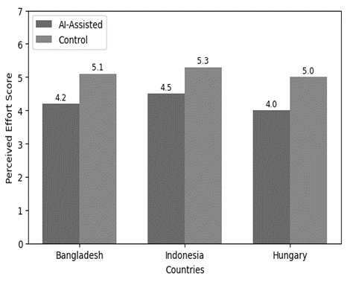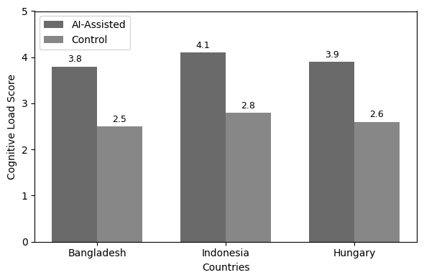
Fig. 1 Comparison of Perceived effort and cognitive load scores by learning condition and country.

4.2 Decline in Higher-Order Thinking under AI Assistance
Figure 2 presents differences in higher-order thinking performance (analysis, evaluation, creation) between AI-assisted and control groups in Bangladesh, Indonesia, and Hungary. In all three countries, the AI-assisted group scored lower than the control group Bangladesh (2.9 vs 3.4), Indonesia (2.7 vs 3.2), and Hungary (3.0 vs 3.5)—with an overall gap of 2.9 vs 3.2 (about 14.9% lower). This suggests AI support lowered immediate complex-task performance, separate from retention results.

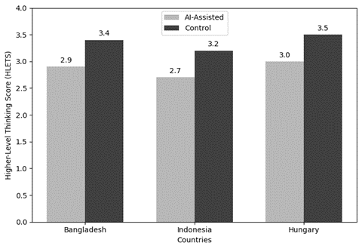 | 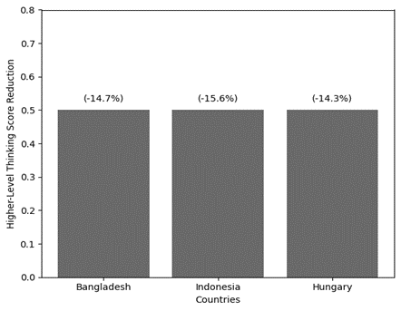
Figure 2. Negative Impact of ChatGPT on Higher-Level Thinking (Analysis, Evaluation, and Creation)
Figure 3 synthesizes the AI cognitive paradox using earlier results on effort, cognitive load, and higher-order thinking in AI-assisted vs. control groups. Consistent with prior findings, the AI-assisted group showed lower effort but higher cognitive load and lower higher-order thinking, indicating a trade-off between ease and cognitive depth based on previously reported results. The right graph in Figures 3 provides a country level breakdown of the perceived effort, cognitive load, and higher order thinking across the three countries.

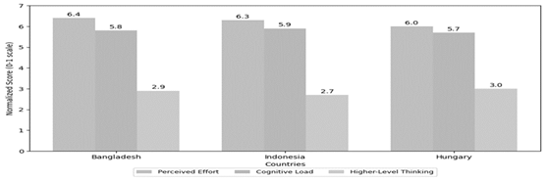
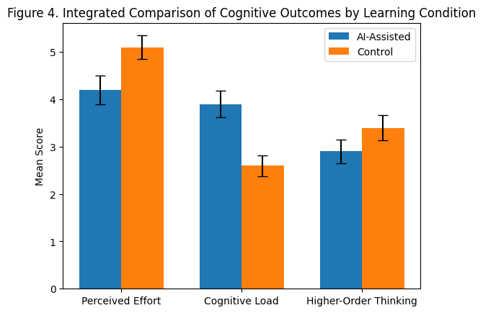
Figure 3. In-depth Examination of GenAI Cognitive Paradox.

4.3 Moderating Role of Metacognition in AI Learning Outcomes
Figure 4 examined how metacognitive awareness moderated learning performance in both AI-assisted and control conditions: across all three countries, high-metacognition students performed better than low-metacognition students, with a larger gap in the AI-assisted group (about 1.1–1.3 points). This suggests GenAI amplifies differences in self-regulation, benefiting learners with stronger metacognitive skills more, and the analysis focuses on the link between metacognitive awareness and performance (not metacognition scores themselves).
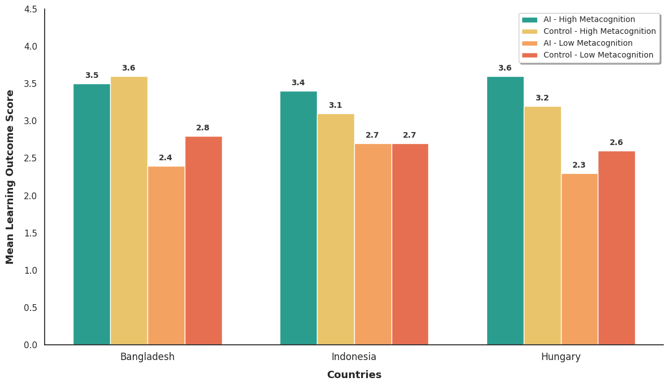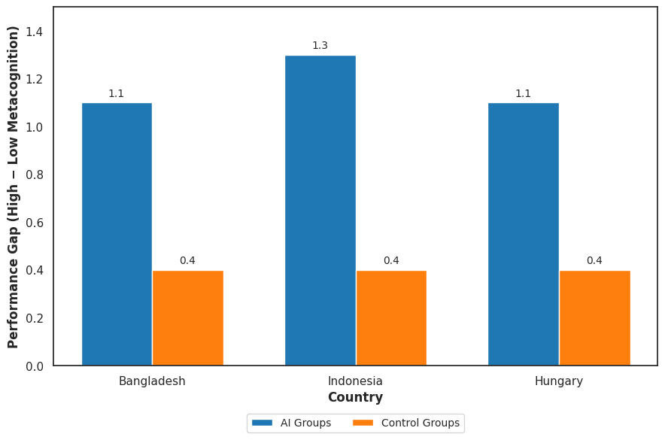
Figure 4. Metacognitive awareness as a moderator of learning performance in GenAI-assisted and control conditions

Figure 5 presents a framework derived from the empirical findings of this study. Specifically, students in the AI-assisted condition reported lower perceived effort but higher cognitive load (Figure 1), while higher-order thinking performance declined by approximately 14–16% compared to the control group (Figure 2). In addition, metacognitive awareness showed a strong moderating effect, with performance differences of approximately 1.1–1.3 points between high- and low-metacognition groups (Figure 4). These results collectively indicate that unstructured use of GenAI may lead to reduced cognitive engagement and unequal learning outcomes. Therefore, the proposed four-phase framework is designed to systematically address these issues by aligning AI use with learners’ metacognitive readiness and promoting progressive cognitive independence.
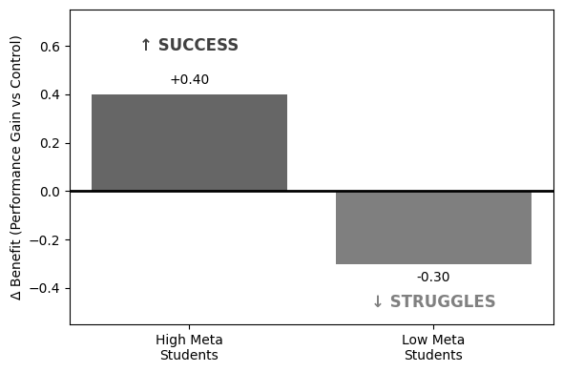
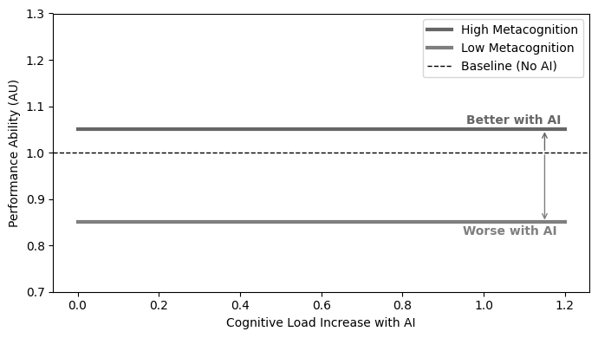
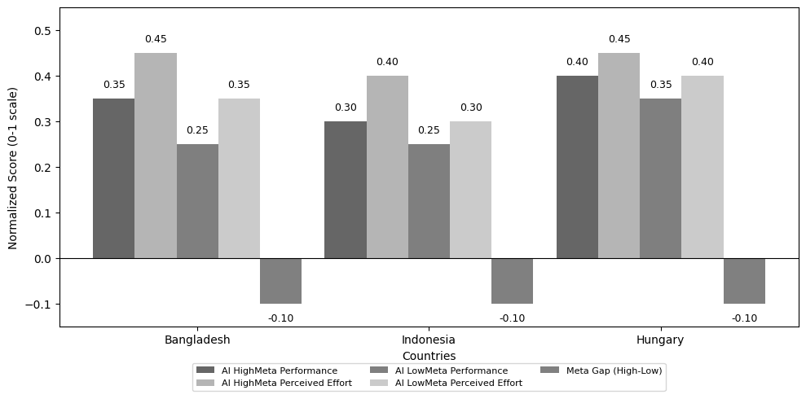
Figure 5: Strategic Framework for Leveraging Metacognition in GenAI-Integrated Education

4.4 Analytical Summary: Cross-Country, Cognitive, and Theoretical Insights
Table 1. Direction and consistency of higher-order thinking effects across countries
Country | Direction of AI effect on higher-order thinking | Consistency with the overall pattern
Bangladesh | Decrease | Yes
Indonesia | Decrease | Yes
Hungary | Decrease | Yes

Table 1 summarizes the direction and consistency of AI’s effect on higher-order thinking across countries, complementing Section 4.2 by highlighting the stability of the pattern across national contexts.
Table 2. Direction and consistency of the overall AI effect on higher-order thinking
Metric | AI Group | Control Group | Difference (Δ)
Higher-Order Thinking (Mean Score) | 2.87 | 3.37 | -0.50
Relative Performance Difference (%) | — | — | -14.9%
Retention of Complex Ideas (Delayed Test) | Lower | Higher | Qualitative (AI < Control)

Table 2 includes an additional indicator on retention of complex ideas, measured using the delayed post-test conducted two weeks after the initial learning session (Section 3.4). While retention results are not separately visualised in earlier figures, this table provides a concise summary of the observed trend. The findings suggest that although immediate performance differences are modest, students in the AI-assisted group demonstrate weaker retention and transfer of complex concepts compared to the control group.

4.5 Verification of Statistical Assumptions: Collinearity, Normality, and Homoscedasticity
Prior to inferential analysis, standard diagnostics confirmed that key statistical assumptions were satisfied: Shapiro–Wilk tests and Q–Q plots indicated approximate normality across variables (p > .05), with minor deviations considered acceptable given group sizes exceeding 30; Levene's tests confirmed homogeneity of variance between conditions (p > .05 in all comparisons); and VIF values below 2.5 in exploratory moderation models indicated no meaningful multicollinearity. These results confirm the suitability of the data for the parametric procedures applied, including independent-samples t-tests, one-way ANOVA, and Pearson correlations.

4.6 Synthesis of Findings: ChatGPT’s Dual Impact on Cognitive Processes
Analysis of Research Question 1 revealed the “AI cognitive paradox”: students in the AI-assisted condition reported lower perceived effort while simultaneously exhibiting higher cognitive load. This pattern indicates reduced subjective strain without a corresponding decrease in cognitive processing demands.
Analysis of Research Question 2 showed that students in the AI-assisted condition scored, on average, 14–16% lower on higher-order thinking tasks than the control group. The analysis was conducted across Bloom’s taxonomy levels (Analyze, Evaluate, Create).
Regarding Research Question 3, delayed post-tests (two weeks later) showed similar factual recall but weaker transfer and synthesis in the AI-assisted group, indicating reduced conceptual integration rather than memory loss.
Analysis of Research Question 4 using a two-way ANOVA and correlation analyses showed a significant moderating effect of metacognitive awareness: students with higher metacognition performed better under AI-assisted learning, while lower-metacognition students benefited less.

4.7 Discussion and Implications
These findings support the misinterpreted-effort hypothesis and highlight the need for learning designs that make cognitive effort visible and meaningful. Authentic, process-based assessments such as comparing, justifying, and critiquing AI- and human-generated work can preserve analytical depth and ethical reasoning (Bjork & Bjork, 1992; Powell & Forsyth, 2025). Effective GenAI integration depends on AI-mediated metacognition, built through AI literacy, reflection, and critical awareness of hallucinations, reasoning limits, and bias (Li, 2023; Turner, 2025). In this context, instructors act as designers of cognitive experiences, guiding students to use GenAI as scaffolding, not substitution.
Overall, GenAI is a dual-edged tool in higher education: it can improve efficiency and support learning when guided by strong metacognitive skills, but it can also promote illusion of learning, cognitive offloading, and weaker critical thinking when used uncritically (Kirk-Johnson et al., 2019; Lee et al., 2025). Effective adoption therefore requires students to become active, self-regulated users of AI, not passive consumers of its outputs.
- Anticipated Contributions and Value
This study provides empirical evidence on the cognitive mechanisms of GenAI-assisted learning. By distinguishing perceived effort, cognitive load, higher-order thinking, and metacognitive moderation, it clarifies how AI affects different dimensions of learning. The findings emphasize the role of self-regulation in AI-supported environments and offer a cognitive-level view of the trade-offs in AI-assisted task completion.
The findings of this study offer several directions worth exploring in future research and practice, though they should be interpreted in light of the study's quasi-experimental design, limited sample size, and two-week timeframe. The observed pattern — in which GenAI-assisted learners reported lower perceived effort yet showed modestly lower performance on higher-order thinking tasks and weaker knowledge transfer — is consistent with the misinterpreted-effort hypothesis and warrants further investigation under more controlled conditions. For researchers, the results suggest that longitudinal and randomised designs, combined with objective cognitive measures (such as eye-tracking or physiological load indicators), would help clarify whether the observed differences reflect genuine cognitive trade-offs or methodological artefacts. For educators and curriculum designers, the moderation effect of metacognitive awareness points tentatively toward the value of building self-monitoring skills alongside AI tool use — for example, through reflective prompting or structured AI-use documentation — though more evidence is needed before these approaches can be broadly recommended. For policymakers, the data do not support blanket restrictions on GenAI use; rather, they underscore the need for context-sensitive guidance that accounts for students' self-regulatory skills and disciplinary demands. These suggestions are exploratory rather than prescriptive, and future multi-site, randomised studies with larger samples will be necessary to establish causal claims.
- Limitations
This study has several methodological limitations that temper the strength of its causal claims and the scope of its generalisability. The non-randomised, quasi-experimental design may introduce selection bias and confounding variables — such as differences in student motivation or prior digital literacy — which could distort observed differences in learning and effort outcomes; the effort–cognitive load correlation should therefore be interpreted with particular caution (Paas et al., 1994). The single-assessment, two-week timeframe is insufficient to capture long-term GenAI adaptation, durable strategy change, or delayed learning effects, as cognitive adaptations such as germane load development and schema formation require extended exposure to emerge (Paas et al., 1994). The absence of process-trace data — including prompt logs, keystroke records, time-on-tool metrics, and AI interaction histories — further obscures the mechanisms underlying observed outcomes, limiting the ability to triangulate self-reported measures against behavioural evidence. Future studies would benefit from designs that incorporate prespecified covariates, augment self-reports with behavioural traces, employ richer measures of productive processing, and are adequately powered to detect small interaction and indirect effects. Finally, the focus on management students restricts disciplinary generalisability (Kumari & Sudha, 2026). Taken together, these limitations underscore the need for future research employing randomised designs, longer intervention periods, and larger, more disciplinarily diverse samples.
- Conclusion
This research identified a “GenAI Cognitive Paradox”: students using GenAI reported lower perceived effort but experienced higher cognitive load, suggesting less subjective strain but greater mental processing. It also found a 14–16% decline in higher-order thinking among GenAI users, likely linked to cognitive offloading, shallow integration, and reduced independent reasoning. While GenAI users maintained factual recall, they showed weaker transfer and synthesis, indicating support for task completion rather than conceptual mastery. The study further confirmed that metacognitive awareness strongly moderates outcomes: high-metacognition students benefited more from AI, while low-metacognition students experienced greater strain and poorer performance. These findings offer practical value for educators, students, policymakers, and researchers in designing more nuanced higher education strategies, including personalized scaffolding, stronger learning infrastructure, and longitudinal cross-cultural research.
References

